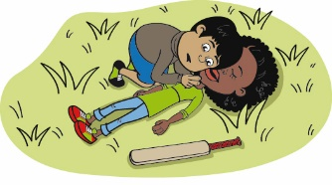
Emergency Action teacher resource – Worksheet
Name
Date
999 or not?

When there is a medical emergency, you need to call 999 for an ambulance.
An emergency is when a person is hurt very badly or they are suddenly very ill.

For each picture, circle the tick if you need to call 999. Circle the cross if it is not an emergency.

Nosebleed  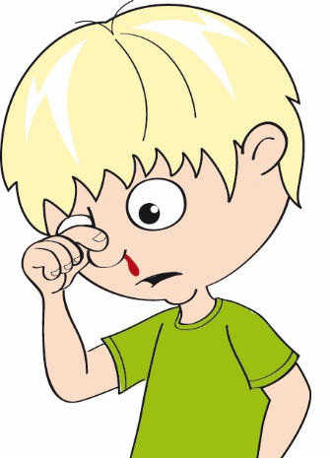 |  | Unresponsive person  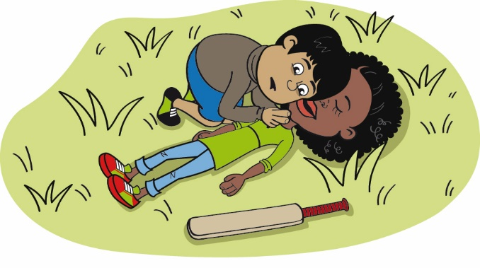

Broken bone  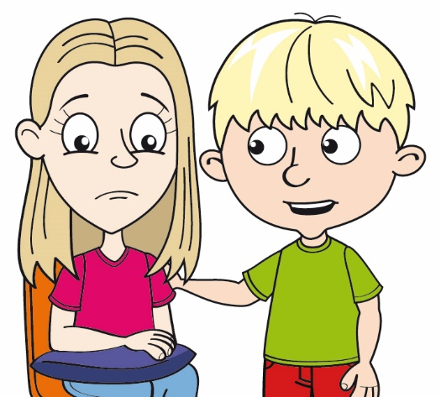 |  | Tummy ache  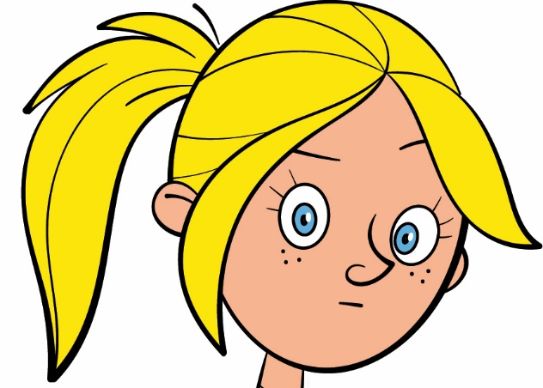

Grazed elbow  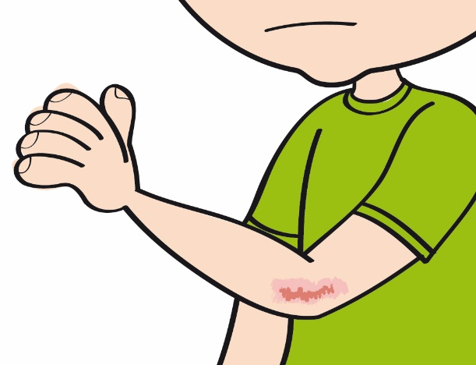 |  | Very bad bleeding from a wound  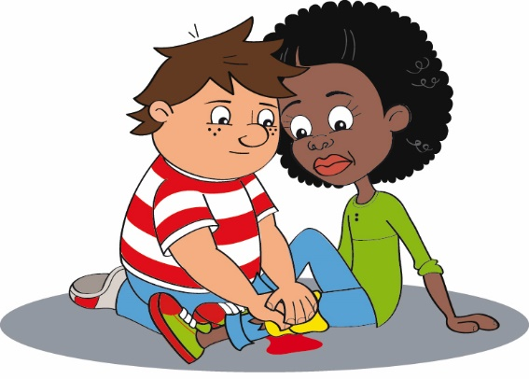

Minor sunburn
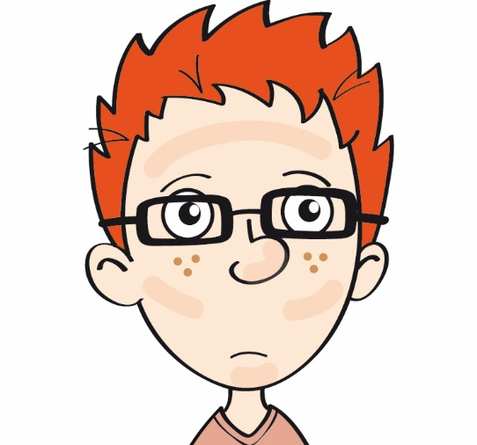

Emergency Action Teacher resource – Worksheet

Name
Date
999 or not?

Think of some more ideas for this chart (not the ones on pages 1 or 2).

Emergency (call 999) | Not an emergency (do not call 999)

