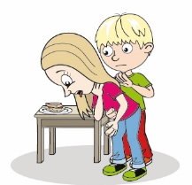
Stay Safe Teacher resource – Worksheet
Name
Date
Risky business

It is good to help other people who have had an accident. But there is a risk – we might get hurt ourselves. There are four examples of accidents below. Write what the danger might be for a person who gives help, and suggest how it can be made safer.

Callum has a cut from broken glass when playing in the park. | Grace has fallen off a bike onto a busy road with traffic.
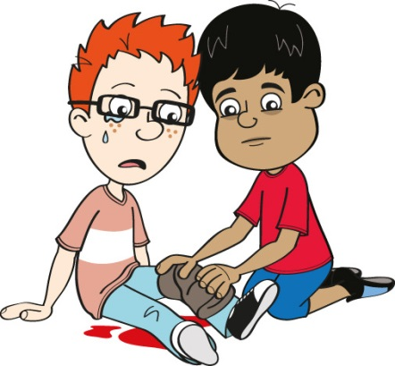  Danger for the helper:  How can it be made safer: | 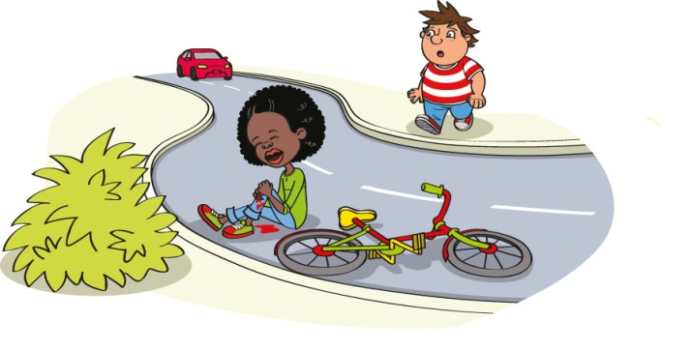  Danger for the helper:  How can it be made safer:

Stay Safe Teacher resource – Worksheet
Name
Date
Risky business

Ryan has burned his hand on a spilt drink of hot chocolate. | Callum has fallen down a ditch and hurt his leg. He has shouted for his friends to help him.
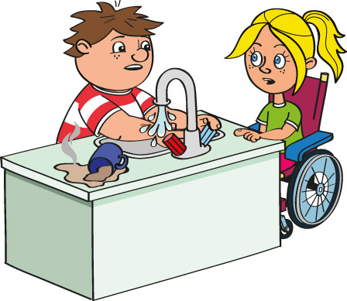  Danger for the helper:  How can it be made safer: | 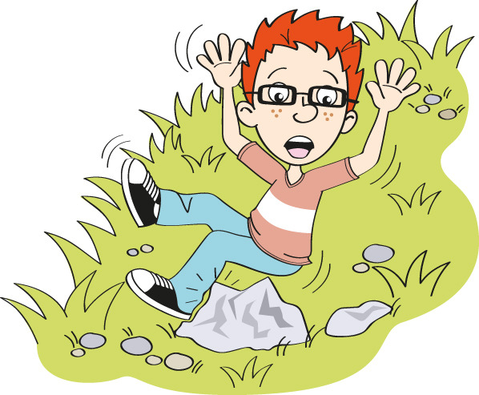  Danger for the helper:  How can it be made safer:

