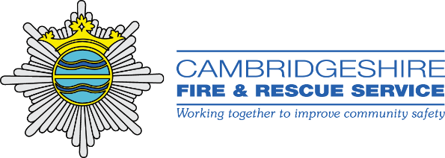

Firebreak
Firebreak is an intensive 5-day intervention programme that provides a positive alternative learning environment.
The programme is carried out within the structured and disciplined environment of the Fire and Rescue Service on an operational fire station and combines classroom based learning with practical activity.
The course offers a unique opportunity for participants to engage with operational firefighters who are given additional training to become Firebreak Instructors. As positive role models they support the participants and help them to build positive and trusting relationships. The course culminates at the end of the week with a pass out parade where participants demonstrate their practical achievements and are awarded their certification in front of invited guests and dignitaries.
Through the Firebreak approach, individuals who may be struggling to achieve within the traditional education framework benefit from the opportunity to develop the skills and knowledge they need to succeed. By challenging themselves in this supportive environment, participants can develop skills around team work and relationship building, focusing on reaching their potential and becoming an active and contributing member of their community.

Who is it for?
The course is available to all young people aged 10-18 but is particularly aimed at addressing a core group of individuals within this age range. Some common characteristics of young people who have most benefited from the course include:
- Young people who have demonstrated risky behaviours
- Young people not currently in education, employment or training
- Young people who are frequently truanting
- Young people with low self-esteem and self-confidence
- Young people identified as gifted and talented.

What do participants gain from the experience?
Reward and certification:
Each participant who completes the course will achieve Unit Award Scheme certificates in; CPR and Basic Life Support, Basic Firefighting Skills and Active Citizenship.
An enhanced practical skills set:
Through both group and one to one engagement with the Firefighters, participants come away from the course with an improved knowledge in areas such as Basic Life Support and Road Safety. They will have learned how to identify and build on their strengths, work as part of a team and improve their level of self-confidence. Improved judgement and awareness: Through classroom based learning and discussion as well as practical exercises and activities, participants are encouraged to understand the consequences of their actions and leave the course better equipped to make well informed decisions for their futures.
Improved attitude to education, training and punctuality:
Through completion of the course, participants learn the importance of commitment, discipline and self-motivation when dealing with challenges and learning new skills. 100% of previous participants have completed the Firebreak Course*, attending every day and completing all activities set within the programme.

What’s included?
- All lead-in/support time with referring agency or establishment
- Full 5-Day programme delivery
- Food and refreshments throughout including breakfast and lunch for each attendee
- Pass-out ceremony in front of guests (attendees are asked to invite family/friends to watch their pass-out parade)
- Award scheme certification where full course is completed
- Follow up evaluation sessions with each attendee at 3 and 6 month intervals following completion of the course.
Referrals to this course can only be made by those working with children and young people, such as the police or a school or agency working with young people and families. To find out more about costs and the Firebreak course, contact us at: firebreakinfo@cambsfire.gov.uk or on 0800 917 9994.
For more information on the wider work of the Cambridgeshire Fire and Rescue Service visit:
https://www.cambsfire.gov.uk/community-safety/our-work-in-schools/

