TOPIC: Choking
To be used in conjunction with the resources for KS2 choking. The Recommended learning age for this topic is 7 – 14 years.
At the end of this topic the learner may be able to:
- identify a casualty who is choking
- assess and give first aid to a casualty who is choking
- understand when to seek medical help for a casualty who is choking
Click here to take our online quiz
Link to this topic on our website:
Click here

Section 1: Recognising a choking casualty
Resources and guidance needed for this session:
PowerPoint slides numbers 1-7
Activity: Drawing paper and colour pencils/pens, printed copies of worksheets (optional)
- This section will help the learner to be able to understand how choking may occur and what is happening inside the body when someone is choking. Use slide 4 to discuss the images and link to the topic. Explain that a baby can be seen in the images and that this age group often put things in their mouths to explore their environment. The middle picture shows a child taking a large bite of food and the adult image is clutching his throat. It is important to recognise that this is a common visual sign of choking.
- Using slide 5 ensure that the learner understands that choking hazards may differ for each age group. e.g. older people may not be able to chew and swallow as well as other age groups and this could potentially result in choking. Next, look at how risks can be reduced: explain the importance of chewing food properly and that walking and talking whilst eating can also lead to choking. Young children should have food cut into small pieces to reduce the choking risks.
- Slides 6 will provide an opportunity to fill in missing words relating to understanding what the process is when food is swallowed and how choking can occur. It should be explained to the learner that normally food travels to the stomach and air goes to the lungs.
- Activity A24 – use this activity to understand the digestive process and the passage of food. Use the template to create a model and discuss how a blockage would affect the flow of air to the lungs.

Section 3: Choking checkpoint
Resources and guidance needed for this session:
PowerPoint slides numbers 8-11
Activity: Your turn choking practical
- Use slide 8 to think about how the casualty might react and how they might feel when they are choking. Be sure to remember that choking would be a scary experience and that if dealing with a choking casualty the first aider needs to remain calm and provide reassurance to the casualty. Check answers on slide 9. The learner could score themself to see how many they answered correctly.
- Activity: Watch the video and discuss key points.
- Using the Your turn sheet on slide 11, use the key steps to learn how to help a casualty who is choking. Create a role play scenario and use this opportunity to practise a call to the emergency services. (role play only NOT an actual call).

Section 2: Treating a casualty who is choking
Resources and guidance needed for this session:
PowerPoint slide number 12-19
Activity: Your turn sheets “choking” and activity sheets A23 and A25
- This section will evidence how well the learning outcomes for the topic have been met by the learner.
- Slide 12 will quiz the learner on the technique of back blows to assist a casualty who is choking and slide 13 requires a word filling activity to be completed that checks learners are aware of the steps to follow.
- Using the Check my learning list on slide 14 can help determine the level of skill and confidence gained, by asking the learner to score the outcomes.
- A word search is available also as an optional activity
Quiz: Ask the learner questions from the quiz below:

# | Question | Answer
1 | Name 3 choking hazards. | Any small items e.g. small pieces of food, coins, beads, pen lids
2 | What number(s) would you ring to get emergency help? | 999 or 112
3 | What is the most important thing and what you must always do first before helping a casualty? | Check for danger or hazards, make sure the area is safe
4 | Why are babies at risk from choking | They put things in their mouth frequently
5 | What steps can be put in place to reduce choking? | Cut food into small pieces, chew properly, don’t talk and eat etc

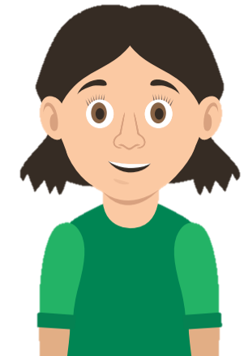
QUIZ
How many correct answers can you get?

# | Question | Answer
1 | Name 3 choking hazards.
2 | What number(s) would you ring to get emergency help?
3 | What is the most important thing and what you must always do first before helping a casualty?
4 | Why are babies at risk from choking
5 | What steps can be put in place to reduce choking?

