The School Games Programme

The School Games is a government led programme designed to keep competitive sport at the heart of schools and provide more young people with the opportunity to compete and achieve their personal best. It consists of different types of competition:
- Personal Challenge
- Intra-School Competition
- Local Inter-School Competition
- County Finals Festivals
- School Games National Finals

The programme is funded by Sport England National Lottery funding and delivered by 450 School Games Organisers (SGOs) across the country.

SGOs are funded by the Department of Health and Social Care and the National Lottery through Sport England to deliver the School Games programme for three days a week. They are predominantly hosted by schools to whom the funding is paid. Outside of this, many SGOs also work as teachers, within School Sport Partnerships or in other roles in sport and schools.

There are 5 SGOs in Cambridgeshire and Peterborough covering the following areas; South Cambs, Cambridge, Witchford (East Cambs & Fenland), Hunts & Peterborough.
The School Games is a fun and enjoyable way of engaging all young people through school sport - either as a competitor, young leader, official, or as part of a media team, focusing on blogging and promoting sport.
Sport can encourage the growth of numerous qualities within young people and the School Games focuses on and celebrates success around six key values: determination, honesty, passion, respect, self-believe and teamwork. These values are called the 'Spirit of the Games'.

You can find out more about the School Games here or by contacting your local School Games Organiser who can tell you how you can get involved.

Claire McDonnell (South Cambs) cmcdonnell@combertonvc.org
Cath Heron (Cambs SSP) cath.heron@netherhallschool.org
Doug Finlayson (Hunts SSP) RDF@hinchbk.cambs.sch.uk
Andrew Phillips (P’Boro SSP) aphillips@stangroundacademy.org
Helen Scotto Di Marrazzo (Witchford SSP) HScottoDiMarrazzo@improveit.ltd

www.yourschoolgames.com

South Cambs School Sports Partnership

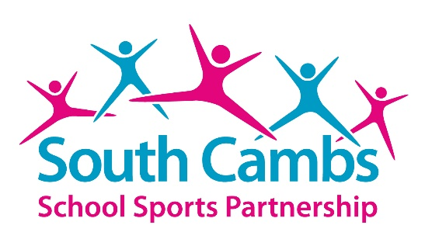

The South Cambs School Sports Partnership (SCSSP) works with 51 primary schools, 9 secondary schools and 1 special school across the district of South Cambridgeshire in order to maximise the positive impact that high quality Physical Education, school sport and physical activity can have on young people. The School Sport Partnership was established in September 2003 and is hosted by Comberton Village College.

Target audience
Primary and secondary staff and pupils

Our Vision
To ensure all young people in South Cambs receive high quality Physical Education (PE) lessons and participate, enjoy and benefit from PE, school sport and physical activity.

Subscription Package
The Partnership offers a popular and successful subscription service to primary schools to support them with delivering high quality PE and to enrich sporting opportunities for all young people. The subscription service is varied and flexible with a ‘Core Offer’ designed to suit the needs of all schools and then a menu of optional ‘Bolt On’ programmes which further support the provision of PE, physical activity and sport in schools. Optional ‘bolt on’ programmes include Pilates sessions, balanceability training, sports roadshows, teaching training, sporting athlete visits, team building days, top up swimming lessons and play leader training for example. This approach offers choice and flexibility enabling schools to tailor their own package of support to suit the needs of their children and school.

See full details in our Subscription booklet here.

Leadership, Coaching and Volunteering Programme
The Partnership runs a hugely successful and popular Leadership Academy programme involving approx. 150 sports leaders aged 14-15years from all of the local secondary schools. Leaders attend two annual conferences plus a celebration event delivered by the Partnership and have access to a broad offer of sport specific leadership awards throughout the year. These leaders are then deployed to support the delivery of extra-curricular clubs, inter school competitions and primary school events as well as guided and encouraged to volunteer in community sport/events.

For more information please contact Claire McDonnell, Partnership Manager cmcdonnell@combertonvc.org

www.scssp.co.uk

Cambridge School Sports Partnership

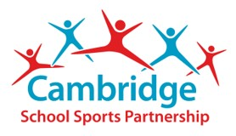

The Cambridge School Sports Partnership (CSSP) works with 34 primary schools, 9 secondary schools and 1 special school across Cambridge city in order to maximise the positive impact that high quality Physical Education, school sport and physical activity can have on young people. The School Sport Partnership was established in September 2003 and is hosted by Netherhall School.

Target audience
Primary and secondary staff and pupils

Our Vision
To ensure all young people in Cambridge receive high quality Physical Education (PE) lessons and participate, enjoy and benefit from PE, school sport and physical activity.

Subscription Package
The Partnership offers a popular and successful subscription service to primary schools to support them with delivering high quality PE and to enrich sporting opportunities for all young people. The subscription service is varied and flexible with a ‘Core Offer’ designed to suit the needs of all schools and then a menu of optional ‘Bolt On’ programmes which further support the provision of PE, physical activity and sport in schools. Optional ‘bolt on’ programmes include Pilates sessions, balanceability training, sports roadshows, teaching training, sporting athlete visits, team building days, top up swimming lessons and play leader training for example. This approach offers choice and flexibility enabling schools to tailor their own package of support to suit the needs of their children and school.

For more information please contact Cath Heron, Partnership Manager cheron@netherhallschool.org

https://www.cambridgessp.com/

Hunts School Sports Partnership
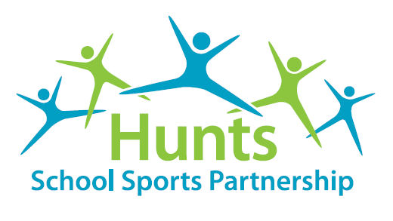

The Hunts School Sports Partnership (HSSP) works with 58 primary schools, 7 secondary schools and 2 special schools across the district of Huntingdonshire in order to maximise the positive impact that high quality Physical Education, school sport and physical activity can have on young people. The School Sport Partnership was established in September 2003 and is hosted by Hinchingbrooke School.

Target audience
Primary and secondary staff and pupils

Our Vision
To ensure all young people in Huntingdonshire receive high quality Physical Education (PE) lessons and participate, enjoy and benefit from PE, school sport and physical activity.

Subscription Package
The Partnership offers a successful subscription service to primary schools to support them with delivering high quality PE and to enrich sporting opportunities for all young people. The subscription service offers the schools 3 levels (Bronze, Silver or Gold) or the option to create a bespoke package for their school alongside a menu of optional ‘Top Up’ programmes which further support the provision of PE, physical activity and sport in schools. Optional ‘Top Up’ programmes include balanceability training, sporting challenges days, teaching training, team problem solving days, top up swimming lessons and play leader training for example. This approach offers choice and flexibility enabling schools to tailor their own package of support to suit the needs of their children and school.

Leadership, Coaching and Volunteering Programme
The Partnership runs a popular Leadership Academy programme involving approx. 100 sports leaders aged 13-15years from 4 of the local secondary schools. Leaders attend an annual launch event delivered by the Partnership and have access to a broad offer of sport specific leadership awards throughout the year. These leaders are then deployed to support the delivery of inter school competitions and primary school events as well as guided and encouraged to volunteer in community sport/events.

For more information please contact Doug Finlayson, Partnership Manager rdf@hinchbk.cambs.sch.uk

http://www.huntsssp.org/

Witchford School Sports Partnership

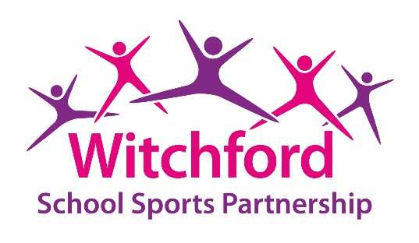

The Witchford School Sports Partnership (WSSP) works with 51 primary schools, 8 secondary schools and 3 special schools across the district of East Cambridgeshire and Fenland in order to maximise the positive impact that high quality Physical Education, school sport and physical activity can have on young people. The Partnership was established in September 2005 and was hosted by Witchford Village College. In September 2016, WSSP moved away from the college and now works independently whilst still maintaining close links with Witchford Village College.

Target audience
Primary and secondary staff and pupils

Our Vision
To ensure all young people in East Cambs and Fenland receive high quality Physical Education (PE) lessons and participate, enjoy and benefit from PE, school sport and physical activity.

Subscription Package
The Partnership offers a popular and successful subscription service to primary schools to support them with delivering high quality PE and to enrich sporting opportunities for all young people. The subscription service is varied and flexible with a ‘Core Offer’ designed to suit the needs of all schools and then a menu of ‘Additional Services’ which further support the provision of PE, physical activity and sport in schools. Optional ‘Additional Services’ include a variety of training packages for teachers, midday supervisors and young leaders. We also offer a variety of event days including team building, orienteering, sport stacking, healthy lifestyles and lots more. This approach offers choice and flexibility enabling schools to tailor their own package of support to suit the needs of their children and school.

For full details of our Subscription, please visit our website.

Sport Stacking
Since December 2019, we have been involved in developing sport stacking in our schools and nationally. Sport stacking is a great activity for both sporty and non-sporty children. There are many activities children can do which not only practice the stacking sequences but gets them moving and active without them realising it. There are many benefits to stacking which include: developing co-ordination and physical skills, confidence, resilience and self-belief.

For more information please visit: www.speedstacks.uk

For more information please contact Di Baker, Partnership Manager
DBaker@improveit.ltd

Charlotte Murfitt, Company Operations Manager – CMurfitt@improveit.ltd
Helen Scotto di Marrazzo, Competition Organiser – HScottoDiMarrazzo@improveit.ltd

www.improveit.education

