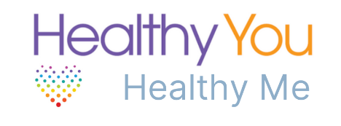
Target: KS1 - 2
Healthy You Healthy Me and Active 4Ten have been designed as a pick-up and go resource, ideal if you are wanting to plan a healthy eating week.
With 5 lesson plans, presentations, resource packs and classroom workouts for both KS1 and 2, we hope to inspire your children and support your school to embed physical activity and healthy eating into daily lives. Please follow the links below to access the resources.

Healthy You Crew: A chance for the children to take charge! As healthy eating ambassadors, your chosen ‘crew’ will have 5 challenges to complete, sharing their new knowledge and activities with the wider school and spreading the positive messages about healthy living.
Schools will recruit 4-6 ‘Healthy Eating Ambassadors’ – ideally Y5 pupils. The ‘Healthy You Crew’ will gain access to online sessions focused on healthy eating/nutrition, at a time that suits them. Each session will end with a small challenge/task for the Healthy You Crew to take to the wider school to complete.

To access the resources visit:
Healthy You Healthy Me
Healthy You Active 4 Ten
Healthy You Crew
If you would prefer to talk to someone about the specific needs of your school, please contact – HealthySchools@healthyyou.org.uk

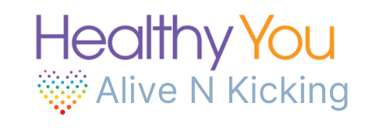
Target: KS2
Healthy You, Alive N Kicking is a six-week programme for year 5 and 6 pupils, delivered virtually or in-school by Nutritionists and Physical Activity Specialists. Through a combination of interactive nutrition workshops and fun exercise sessions, we aim to raise awareness of healthy eating and physical activity, and to allow children to explore how they can positively impact their own lives through food and activity choices.

Each one-hour class will cover topics including Eat Well Guide and Breakfast, 5-a-Day, Food Safety and Cooking Skills, School Lunches, Sugars, Fast food and Snacks. The physical activity component will either be games-based activities in-school, or a series of pre-recorded videos including interval training and strength-based exercises.

Take home materials and homework challenges will encourage the whole family to get involved. Parents will also receive a guide which contains information and resources that are delivered during the programme.

For more information visit: Alive N Kicking
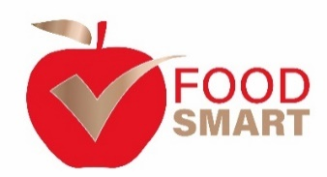
Target: KS1 - 4
Food Smart is designed to support primary and secondary schools, to adopt a whole school positive approach towards healthy eating, food and nutrition.

All elements can be accessed separately or combined according to need and facilitate the requirements of the new Health Education Curriculum. Food Smart comprises of:

- Assemblies – virtual and in-school
- Self-led Lesson Plans & Resources
- Student and/or Parent Workshops
- Teacher Training Opportunities
- A Skills Passport to facilitate essential food preparation and cooking techniques
- Links to local businesses, initiatives & other food related networks
- Food Smart Accreditation

Our progressive accreditation scheme offers three levels: bronze, silver and gold which focuses on; food provision, leadership, food education and engaging with the community. We also offer a bespoke program of support to those taking part to ensure success.

For more information visit: Food Smart

