Cambridgeshire Fire and Rescue Service
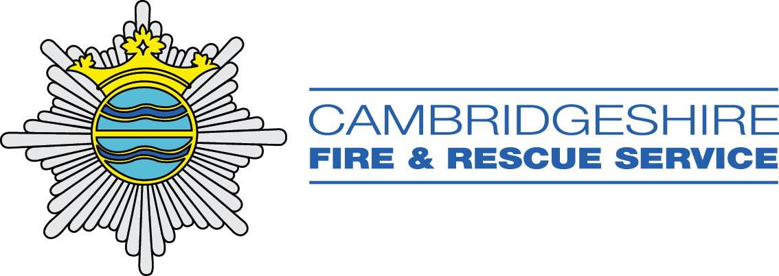

Contact:
joe.gacon@cambsfire.gov.uk
odette.tattersall@cambsfire.gov.uk
Key Stage | Type of Intervention | Description of Content
KS1 | Download of videos and content about the Fire Service with teacher/parent notes | Jet the Firefighting Dragon is targeted at Yrs 1- 3 and addresses Fire, Water and Beach safety though a video, story and a teacher/parent guidance pack. Find out more here:  Come and play! (cambsfire.gov.uk)  Objective (cambsfire.gov.uk)
KS2 | Delivery in person or virtually  Safety Zone booklets to complete in conjunction with other services | Presentations are available for Fire, Water and Road Safety and cover the following:  Fire Safety: Escape routes, testing smoke alarms, calling the fire service, not playing with fire, charging phones at night and knowing the home address.  Water Safety: Float to live, throw lines, rescue techniques  Road Safety: Crossing the road safely, bike helmets, blind spots and visible clothes.
KS3-5 | Firebreak One – an intensive one-day training course delivered by members of the Fire and Rescue Service | A day’s training designed to promote resilience, healthy relationships, self-efficacy and aspirations. The training is held at a fire station and is targeted at students from Y7.  To find out more about Fire Break One and costs:  Contact: firebreakinfo@cambsfire.gov.uk  Call: 08009179994  Visit: Firebreak One (1 Day) - Healthy Schools (healthyschoolscp.org.uk)
KS3-5 | Firebreak Five – an intensive five-day intervention programme delivered by members of the Fire and Rescue Service | This programme combines classroom-based learning with practical activity to develop skills around teamwork and relationship building and to encourage active and responsible community engagement. The programme (based at a local fire station) is targeted at young people between the age of 10 – 18 who are struggling to achieve within the traditional education framework.  To find out more about Firebreak Five and costs:  Contact: firebreakinfo@cambsfire.gov.uk  Call: 08009179994  Visit: Firebreak (5 Day) - Healthy Schools (healthyschoolscp.org.uk)

