Food & Mood Teaching Resources:

 | Food | Why | What
 | Protein | High levels of Dopamine & Norepinephrine | Concentration, Pleasure and mood regulation
 | Fruits & Vegetables | High in vitamins, minerals & antioxidants | Happiness
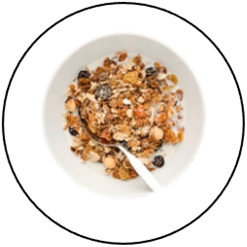 | Healthy Fat & Fibre | Stabilise blood sugar | Lifts mood and reduction in anxiety
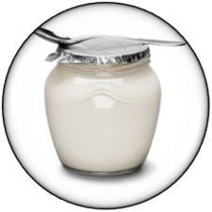 | Fermented food | Support growth of healthy bacteria in the gut. The gut produces serotonin | Happiness
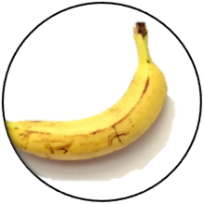 | Bananas | Vitamin B6 which synthesises dopamine & serotonin | Happiness
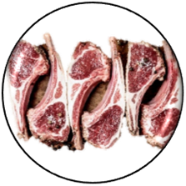 | Red meat | Iron | Less likely to feel weak and tired
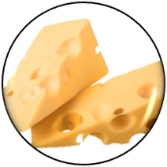 | Dairy | All B vitamins | Less likely to feel irritable
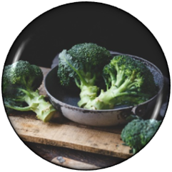 | Green vegetables | Folic Acid | Less likely to be depressed
 | Carbohydrate | Glucose | Brain power (concentration)
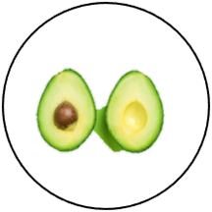 | Anti-inflammatory foods (Avocados) | Lower Cortisol | Stress reduction
 | Seafood (Crabs) | Zinc | Improved immune system
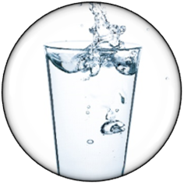 | Water | Hydration | Concentration and can help prevent constipation
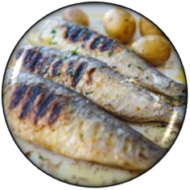 | Fish | Omega 3 | Reduce depression
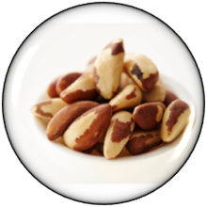 | Brazil nuts | Selenium | Reduces likelihood of low mood and depression
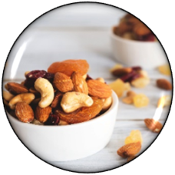 | Almonds | Melatonin | Help internal body clock (improves sleep)

Glossary:
- Antioxidants - A substance that aids us through protecting our cells from harmful molecules such as radiation.
- Cortisol - A hormone that directly impacts the stress cycle. (Our primary hormone responsible for stress)
- Dopamine - A neurotransmitter responsible for the reward centre, so allows individuals to feel pleasure and makes them feel good.
- Folic acid - A vitamin responsible for maintaining a healthy nervous system. It also helps create healthy red blood cells.
- Glucose - A sugar that is the main source of energy / fuel for the body and the cells within the body. It is also blood sugar.
- Iron - A mineral that helps create healthy red blood cells.
- Melatonin - A hormone that aids in sleep regulation. (Fall asleep quicker)
- Norepinephrine - A neurotransmitter as well as a hormone that is responsible for both arousal and alertness.
- Omega 3 - A fatty acid that helps build and maintain a healthy body
- Selenium - An element that helps the immune system
- Serotonin - A neurotransmitter that aids the regulation of mood. (happiness).
- Vitamins - Nutrients that help the body function and maintain healthy.
- Zinc - A nutrient that helps cells grow, keep the body healthy and helps the immune system.

