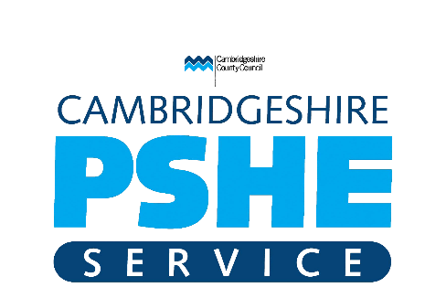
Guidance on addressing misogyny, toxic masculinity and social media influence through PSHE Education.
In recent weeks, there has been a rise in the profile of certain social media influencers who promote misogynistic, racist, homophobic and other discriminatory viewpoints. For many schools, awareness of this issue far preceded the current media focus. The negative effects of these toxic narratives have been noted in our schools for well over a year.
The key issues are that leaving these views unchallenged creates a hostile environment for a wide range of people, perhaps most notably women and girls, but also for those with other protected characteristics, including boys and men who disagree with the discriminatory world view being promoted.
When talking to students about these topics, care should be taken not to build awareness and further the ‘glamourisation’ which is currently evident in the media. Many will be aware of the name Andrew Tate and, as the outcome of his story unfolds, his name will remain high profile. Staff should not encourage the naming of other influencers with similar views and should make it clear that once a person has searched online for this content, algorithms will cause them to be presented with other similar content, possibly creating the false impression that these sorts of views are widely held. Staff should address the negative views and behaviours not the names of individuals and the platforms they use.
Schools should consider areas of their PSHE Curriculum which prevent the acceptance of these views through a range of different approaches. These topics are already covered in the statutory requirements for Relationships Education, RSE and Health Education. Approaches might include:
- At primary, coverage of themes such as respect, equality, identifying the negative effects of stereotypes, including the negative effect on aspirations, behaviour and self-perception with in the PSHE Curriculum.
- At secondary, coverage of themes such as treating others respectfully, awareness of online and media influences, identifying discrimination and radicalisation as part of the PSHE Curriculum.
- Exploration of the methods used by online influencers to package toxic world views within more wholesome messages about health and fitness, creating a false sense of validity.
- Presenting an alternative world view of respectful relationship which enable all people to flourish and enabling students of all genders to see and hear positive role models, including staff members who challenge the toxic narrative.
- Allow space for discussion within the safe learning environment you have set up in your PSHE classrooms.
- Recording and reporting prejudice language and behaviours using you usual safeguarding procedures and the PRfE tool, to which all schools in Cambridgeshire and Peterborough have access. Prejudice Reporting for Education (PRfE). If you need support to login contact support@prfe.education
It is essential that all discriminatory language and behaviour is responded to consistently by all adults in our schools. All Cambridgeshire and Peterborough secondary schools have access to the Safer Corridors Pupil Voice Toolkit. All Cambridgeshire and Peterborough primary schools have access to the Safer Spaces Toolkit. Both of these packs provide activities and approaches which support young people in identifying and challenging sexist and misogynistic behaviours in age-appropriate ways. Schools may access either toolkit by following the links. Briefings on their use are available by contacting cathy.murphy@cambridgeshire.gov.uk at the PSHE Service.
Schools may also wish to access training for staff on building awareness and consistent responses to sexist and misogynistic behaviours and sexual harassment. This can be accessed from the PSHE Service.
This advice reflects the content of the PSHE Association’s Guidance ‘Addressing misogyny, toxic masculinity and social media influence through PSHE education’ which is available to PSHE Association Members here.
This guidance is available to all:
Handling complex issues safely in the PSHE classroom.pdf (hubspotusercontent-na1.net)
Schools who are interested in promoting positive modes of masculinity with boys and young men, might be interested in the resources from Being Mankind.
Further guidance is avaible from A Review of Harmful Content Online - Ineqe Safeguarding Group

