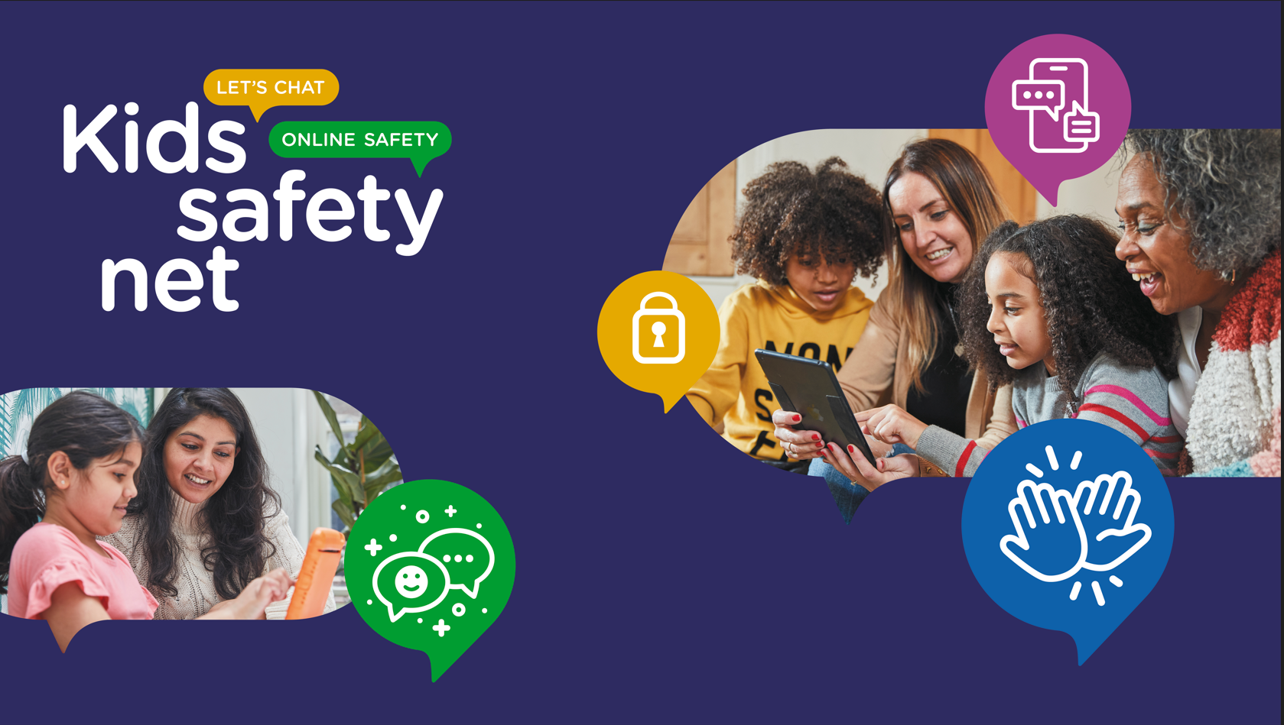
Respect and Consideration Online – 2024
COMPETITION PROJECT BRIEF
Open to Schools for Year 5 to Year 8 Pupils
Closing Date: 4pm Friday 21st June 2024

Respect and Consideration Online
Project Brief:
This competition is intended as a whole class competition, putting schools against one and another, you are encouraged to approach this as a project, supporting e-safety and PSHE teaching and learning over a number of weeks to produce a purposeful final presentation for the benefit of your school community.
Your task is to work toward a presentation to support the development of respectful online behaviours, recognising the difference between healthy friendships and unhealthy friendships and to know who to go to for support if something does not feel right. The presentation can be in any format you wish, this could be a short play, a display for a presentation board within the school, or as a toolkit that can be shared with others.
The aim:
- This work will be shared with the wider school community which may include peers and or parents.
- To demonstrate knowledge and understanding of the issues for this age group.
- To communicate important messages around online safety and how others can keep safe online, knowing where to go for help and support if required.
The core theme of your presentation should be around healthy online friendships, and behaviours with friends and knowing how to identify a friendship that may not feel healthy. You are encouraged to consider the experiences of your pupils and how, as a peer group, they might encourage positive online behaviours and the actions they might take if/when things go wrong.
The following questions should guide your thinking and class delivery whilst developing your presentation plan:
- What issues are your class/school could be experiencing?
- How can individuals support each other to make responsible decisions for positive outcomes, including pupils, parents, and school staff?
- What medium will best present your message(s) clearly, so it is easily understood
- How will you review the success of your task?
- The Copyright and referencing needs of any content that you have used in your presentation.
Entrant submissions should demonstrate this, with the following:
- An outline plan of what is to be included in the presentation.
- A student reflection of the school’s AUP and a copy of any they may have develop for their own family/peer group use.
- Evidence of the final presentation. This might comprise of photographs, audio/video clips or a digital copy of the final piece. *Schools should consider parental permissions for any pupil imagery for the final piece
- A review of the final piece. This might be as a class reflection, and/or feedback provided from the wider school community such as the Head Teacher, another class and or parent/carers.
Judging Criteria:
Note that submissions will be judged by members of the NSPCC, the ICT Service and the PSHE Service. The panel of judges will mark submissions based on the following criteria of:
- A core issue experienced by members of the class has been identified
- A clear plan of what messages are to be presented in the final piece has been outlined
- A student reflection of the school’s AUP has been submitted
- Appropriateness of the presentation choice for the identified outcome
- The presentation supports the outline plan
- The message is clearly conveyed
- Positive outcomes have been identified
- Copyright content has been referenced
- A review of the final piece has been evidenced. This might be a class reflection, or feedback received from demonstrates planning, purpose, and reflection.

* Should the winning and runner-up final presentation include any images of pupils, the school will be asked to complete the NSPCC parent consent forms for all pupils who appear in the final presentation so that it may be shared online to a wider public audience.
CLASS WORKBOOK
PROJECT NOTES
Class name: | Click or tap here to enter text.
School name: | Click or tap here to enter text.
Class teacher/Main contact: | Click or tap here to enter text.
Core issues your presentation focuses on (Being kind and inclusive in social media/chat, dealing with issues/conflict) | Click or tap here to enter text.
Reflection on AUP (how well do we use it/what do we not use so well, does it cover core issues?) | Click or tap here to enter text.
How we intend to present our project work (Online content, assembly/class play, digital/physical display board in school/in a public place…) | Click or tap here to enter text.
What we intend to include in our presentation (static images, audio/video, posters, links, documents, surveys…) | Click or tap here to enter text.
Intended audience
Other notes: | Click or tap here to enter text.
REFLECTION
Did this piece turn out as intended? | Click or tap here to enter text.

